

Lab Final

|  |  |  |  |  |  |  |
| --- | --- | --- | --- | --- | --- | --- |
| **Only for course Teacher** | | | | | | |
|  | | **Needs Improvement** | **Developing** | **Sufficient** | **Above Average** | **Total Mark** |
| **Allocate mark & Percentage** | | **25%** | **50%** | **75%** | **100%** | **40** |
| **Understanding/Analysis** | **10** |  |  |  |  |  |
| **Implementation** | **15** |  |  |  |  |  |
| **Accuracy** | **10** |  |  |  |  |  |
| **Task Efficiency** | **5** |  |  |  |  |  |
| **Total obtained mark** | | | | | |  |
| **Comments** |  | | | | | |

**Semester: Spring 25**

**Student Name: Md.Sihab Mahmud Uthso**

**Student ID: 232-35-297**

**Batch: 41 Section: H2**

**Course Code: SE-224 Course Name: Database System Lab**

**Course Teacher Name: Md. Ashikur Rahman**

**Designation: Lecturer**

**Submission Date: 16 /4/25**

**Part1:**

**a)**

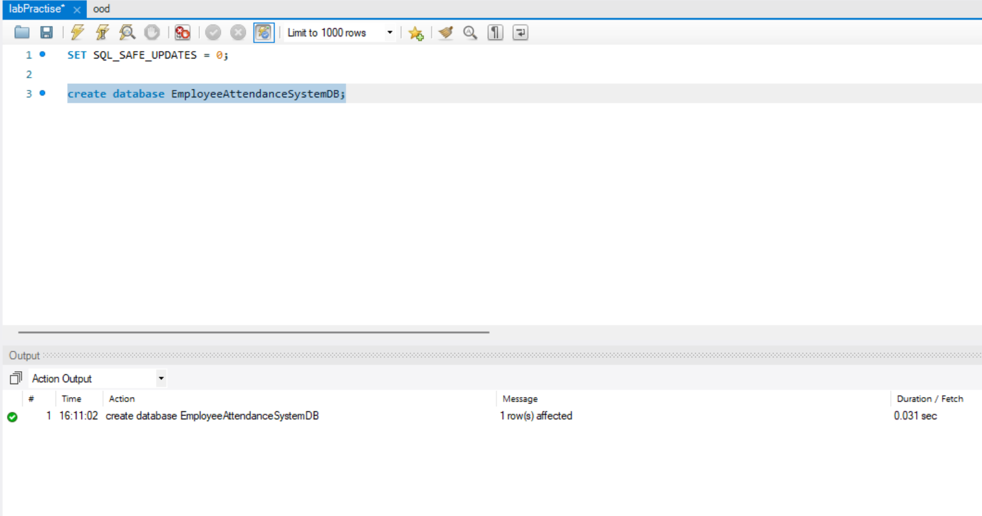

**b)**

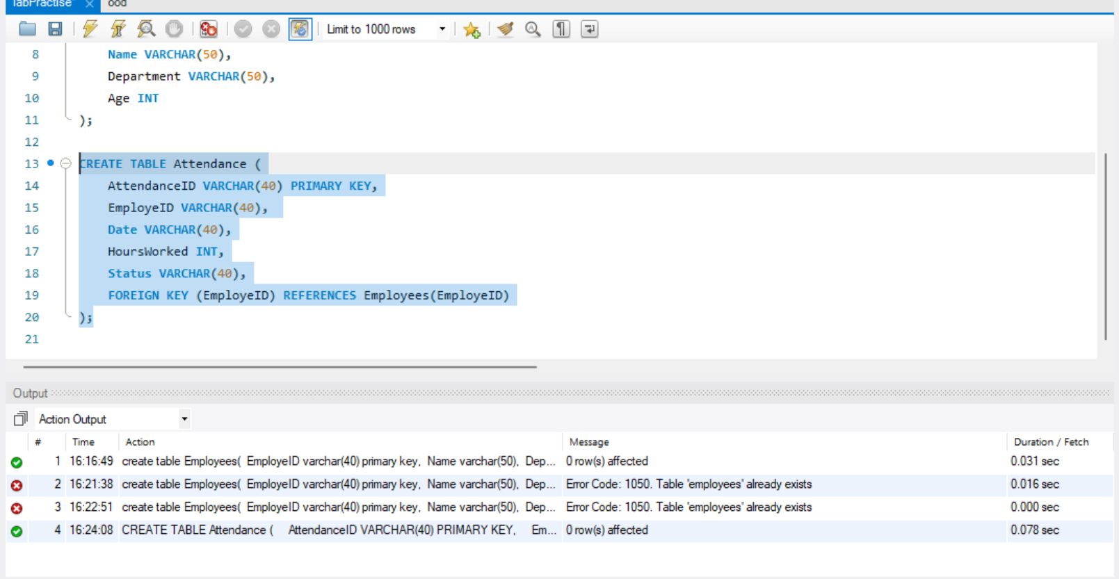

**c)**

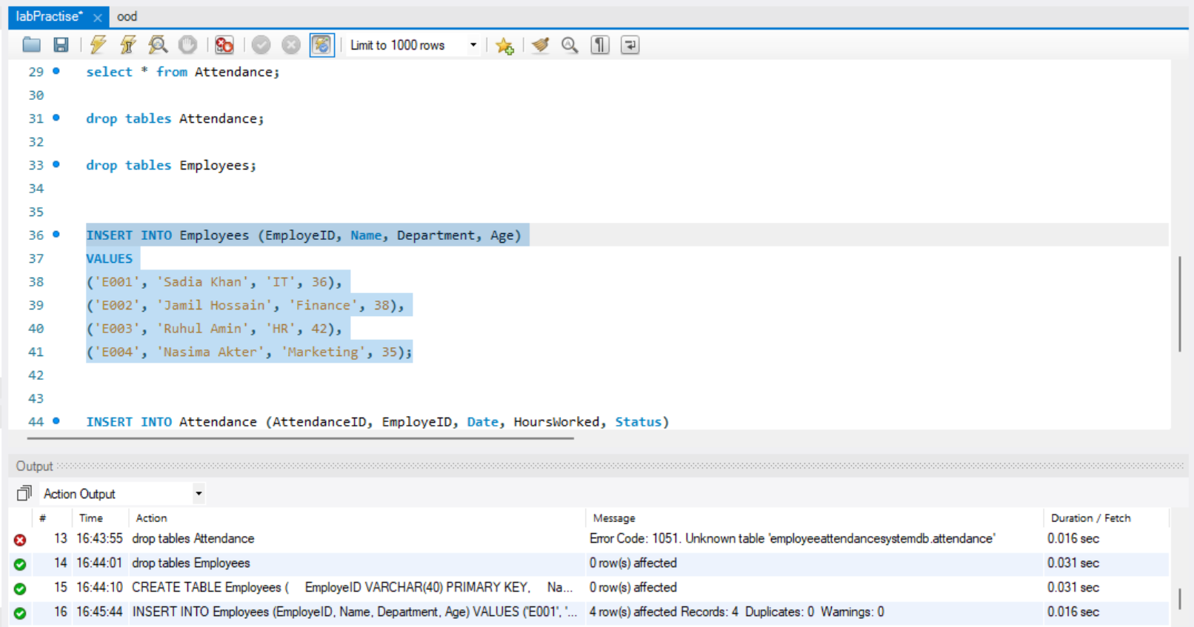

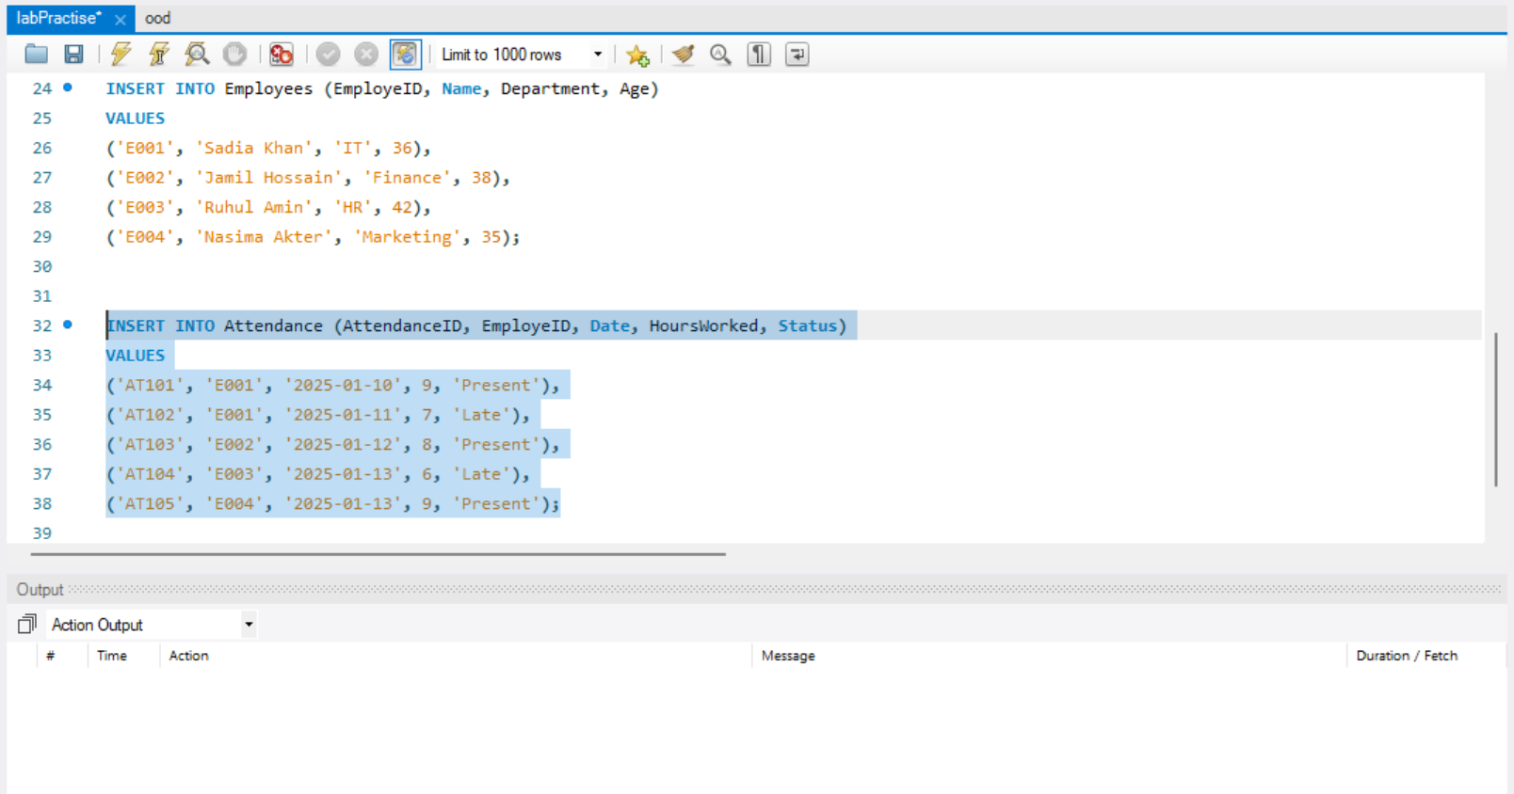

**Part2:  
a)**

**alter table Employees add column Email varchar(50) not null;**

**b)**

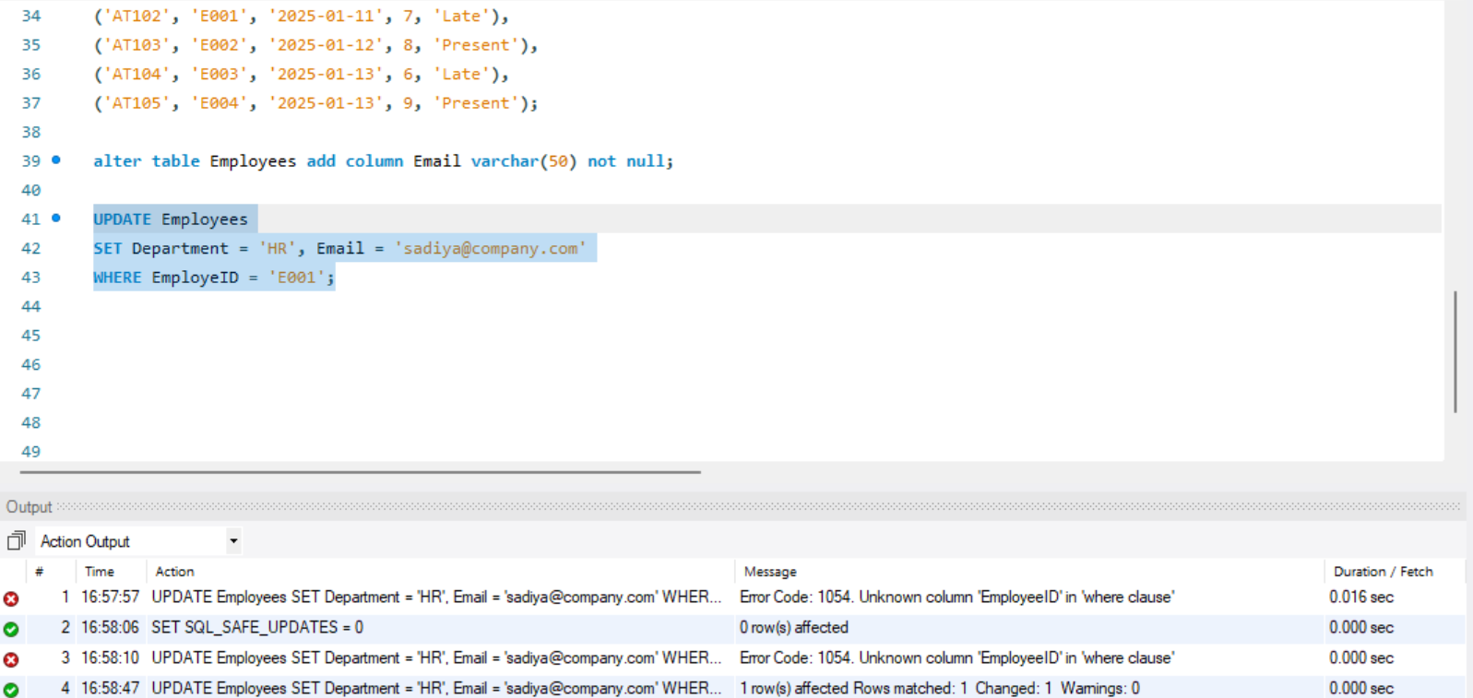

**c)**

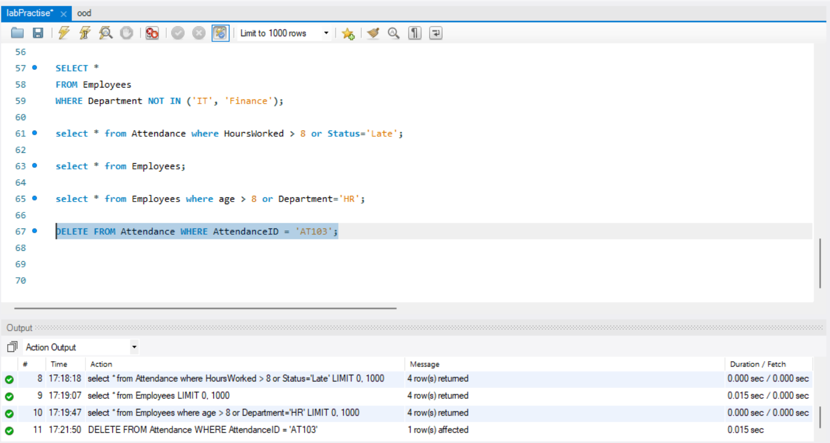

**Part3:  
a)**

**SELECT EmployeID, AVG(HoursWorked) AS AvgHours**

**FROM Attendance**

**GROUP BY EmployeID;**

**b)  
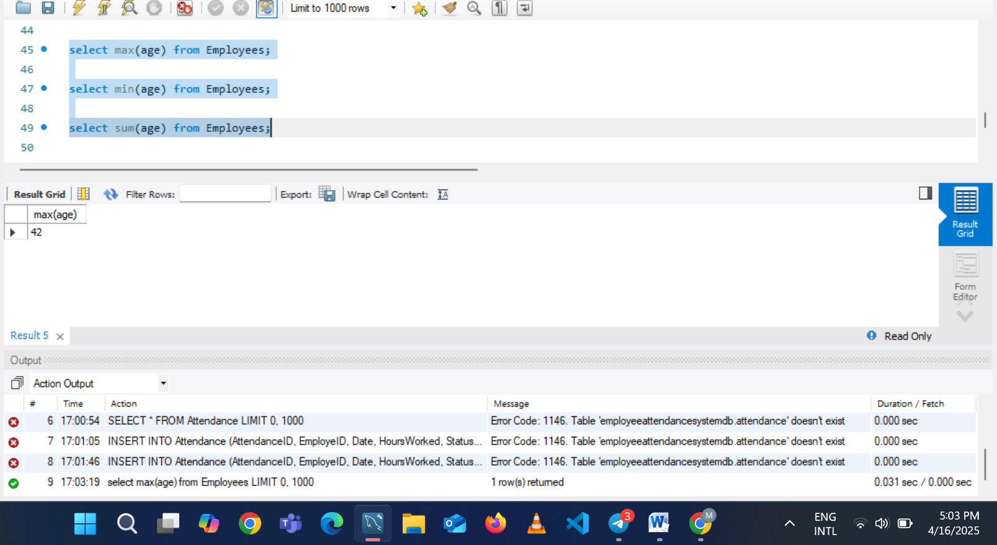**

**Part 4:  
a)**

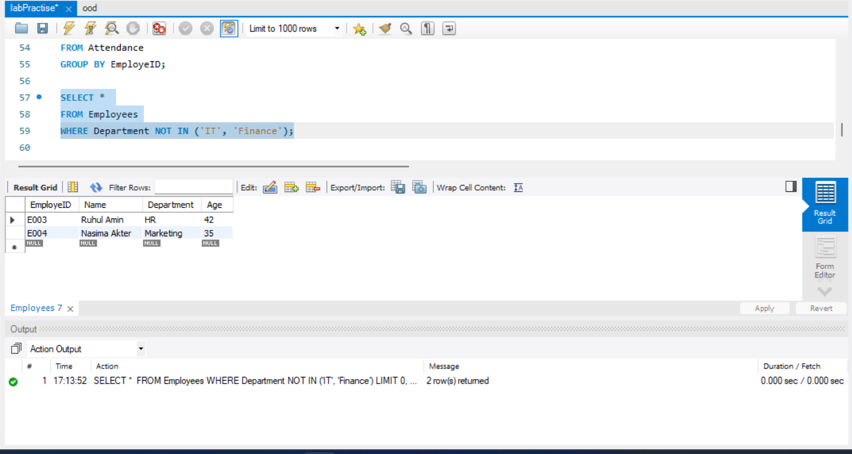

**b)**

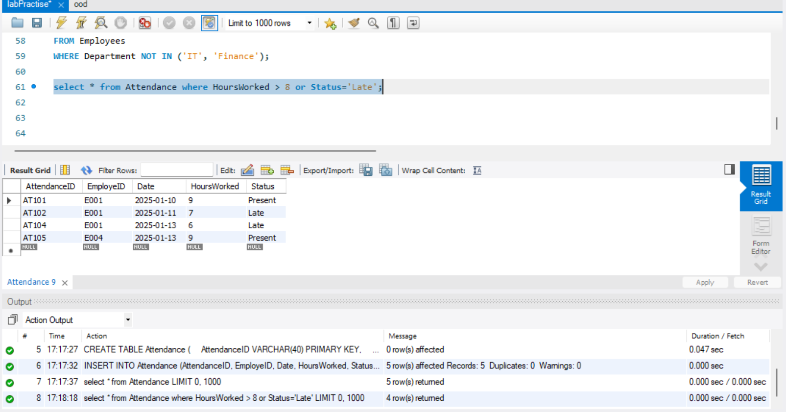

**c)**

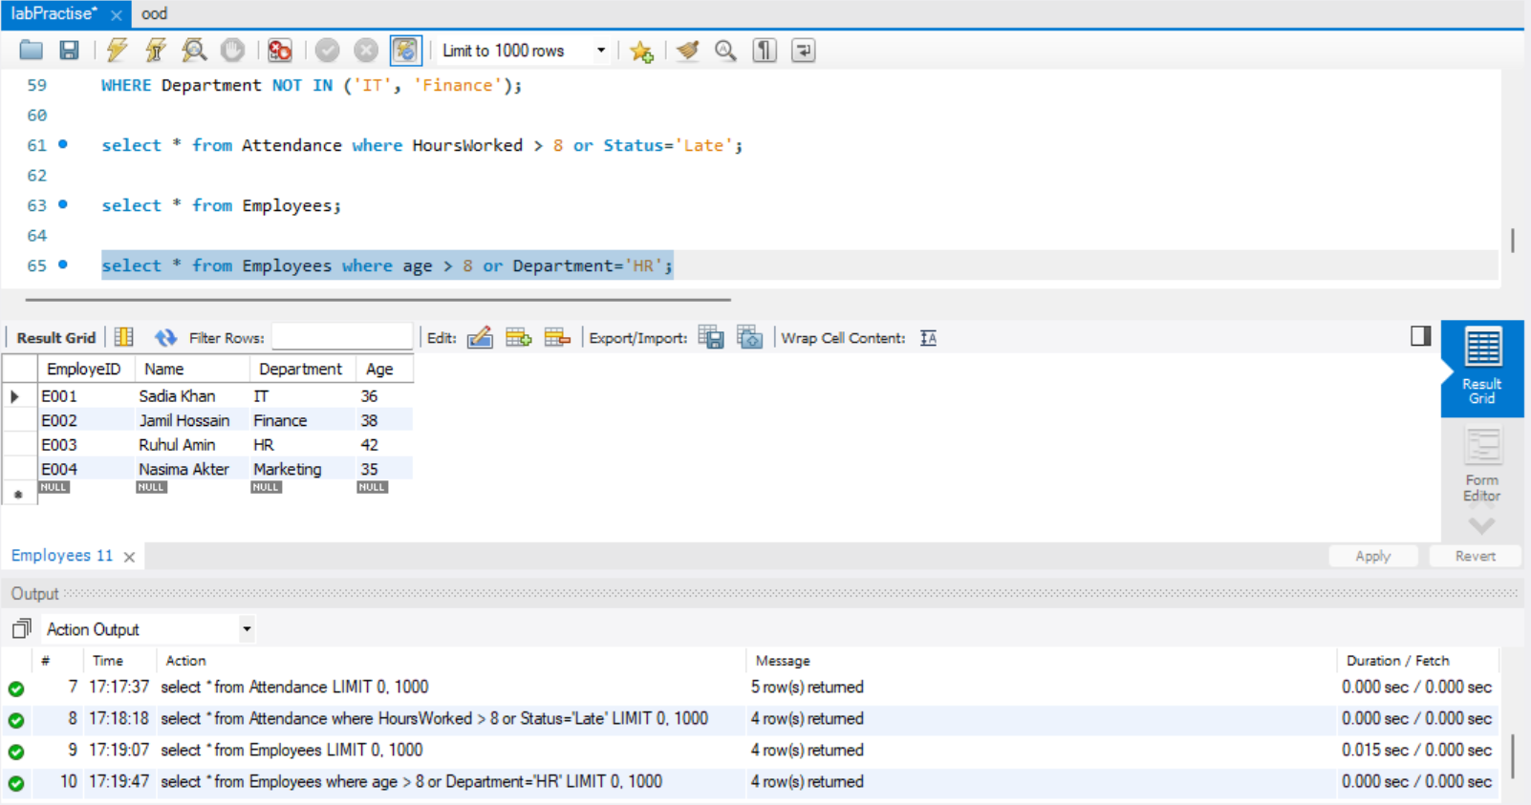

**Part 5:**